Title:

What's the Best Way to Find and Buy a Foreclosed Home

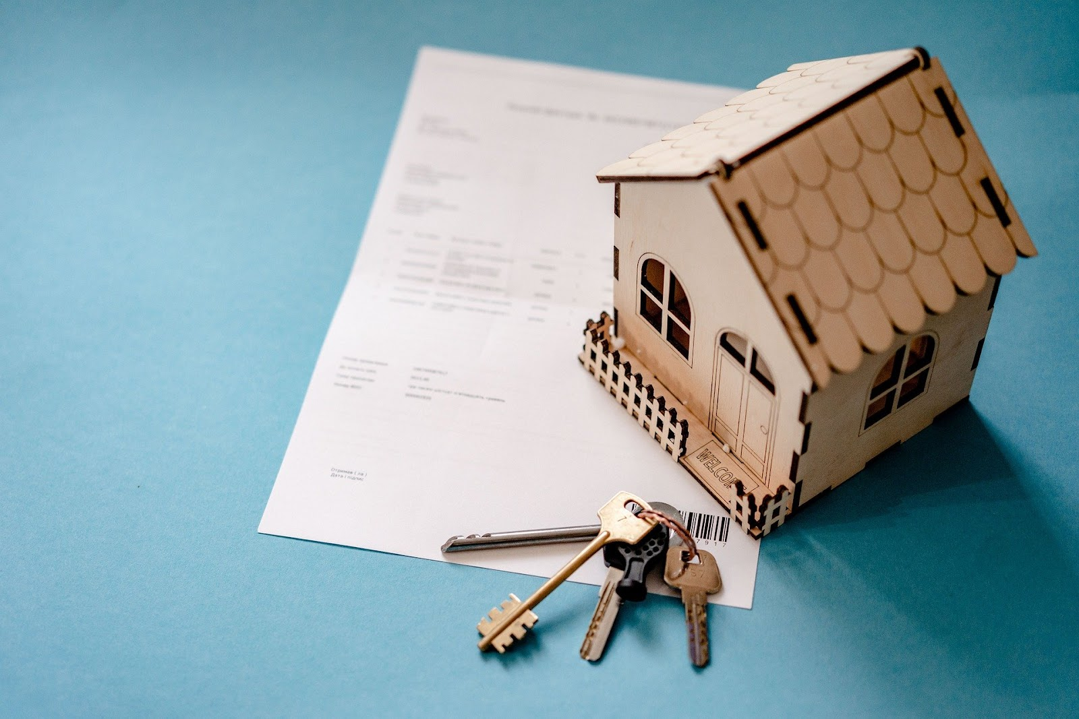
Image Credit: VisionPics from Pixabay.
Finding and buying a foreclosed home used to be a tricky process, but it’s become increasingly easier over the past decade or so. That’s led more and more real estate investors to be attracted to the niche. Figuring how to buy a foreclosed home isn’t quite so simple, however.
It’ll still take some time, work, and the investment itself, and possibly some help from well-trained experts. With a bit of effort - and maybe a little research - figuring out how to find a foreclosed home and buy it can be as straightforward as following a few steps.

How to Find a Foreclosed Home
Before you can buy, you’ll need to find out how to find a foreclosed home. You can find many listings online, with real estate sites and even foreclosure-related banks offering sections dedicated to listings. Finding ones dedicated to the area you’re looking to invest in can be as simple as spending a few hours online.
Multiple trade publications also exist dedicated solely to this. It may also be worth asking local real estate agents about this, as banks are increasingly using them to sell off foreclosed properties. Then there are foreclosure sales, which you may need to know a little more about.

Types of Foreclosure Sale
The foreclosure process has a significant impact on how the property is sold, with there being five types of foreclosure sales to be aware of. These can affect the process itself, making it worth diving into them. They are:
- Pre-Foreclosure - With these, the homeowner is still in the home but has been notified of the foreclosure. They have the potential to sell the property before foreclosure actually starts and avoid the process completely.
- Short Sales - Houses sold in short sales are typically worth less than the outstanding mortgage value, so banks are more likely to sell them at a discount. They’ll be much more open to negotiation.
- Sheriff’s Sale Auction - As the name suggests, these homes take place during an auction, so you’ll be bidding against other potential buyers on the spot, which could drive up the price.
- Bank-Owned Properties - These are properties that don’t sell at an auction or before the foreclosure process finishes. Since ownership reverts to the bank, you’ll need to buy it through them.
- Government-Owned Properties - Some properties are purchased through government-approved grants or loans. When these are foreclosed on, ownership reverts to the government rather than a bank, so you’ll need to negotiate through a government-backed broker.
Now that you know where and how to find them, it’s worth looking into how to buy a foreclosed home. Thankfully, the process should be more straightforward than finding the properties, but you’ll still need to put some effort into various areas.

How to Buy a Foreclosed Home
Once you know how to find a foreclosed home, it’s time to go about buying it. If you don’t know how to buy a foreclosed home, you could be surprised by how simple it is, but there will be some hoops to jump through.
If you’re buying from a bank, you’ll need to make sure your negotiation skills are top-notch, as they’ll help you get the best deal possible. Banks with sizable portfolios of foreclosed properties will be more open to this, especially if the house you’re bidding on has been in their possession for quite a while.
It could be worth bidding 10% to 15% lower than the original asking price. While the bank isn’t likely to drop that low, it’ll end up bringing the eventual sale price down by a bit. At a minimum, you shouldn’t expect to pay too much above the asking price for it, if it goes above the asking price at all.

How to Buy a Foreclosed Home: Wrapping Up
If you don’t know how to buy a foreclosed home, it can seem like a daunting process. You’ll need to go about finding one that suits your investment needs, which can be tricky with fewer and fewer foreclosures occurring.
Outside of knowing how to find a foreclosed house, you’ll then need to go through the actual purchase process. That could be quite easy. With RPI Education, we make things as straightforward as possible. Specializing in educating and empowering investors, we work with you to simplify everything.
Get in touch to see how we can help you on your journey. Buying or investing in a foreclosed home will become much easier than you’d think.

